EXERCISE 15
1. List all employee IDs and birth dates of employees who were born before 1965.
SELECT e_id, birth_date FROM employee_per WHERE birth_date < '1965-01-01';
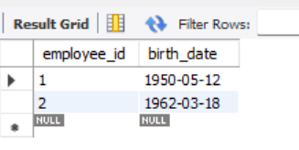

2. Display IDs and birth dates of employees born between 1970 and 1972.
SELECT e_id, birth_date FROM employee_per WHERE birth_date BETWEEN '1970-01-01' AND '1972-12-31';
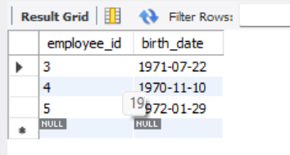

CREATE DATABASE EXERCISE15_ADDRESSBOOK;
USE EXERCISE15_ADDRESSBOOK;
CREATE TABLE employee_data (
employee_id INT AUTO_INCREMENT PRIMARY KEY,
f_name VARCHAR(100),
l_name VARCHAR(100),
birth_date DATE,
email VARCHAR(150),
spouse_name VARCHAR(100),
marital_status CHAR(1),
children INT,
sex CHAR(1)
);
INSERT INTO employee_data (f_name, l_name, birth_date, email, spouse_name, marital_status, children, sex) VALUES
('Kim', 'Mariano', '1950-05-12', 'kim.mariano@email.com', 'Maria Santos', 'Y', 3, 'M'),
('Trisha', 'Kim', '1962-03-18', 'trisha.kim@email.com', 'Ana Lopez', 'Y', 2, 'F'),
('Kim', 'Etucag', '1971-07-22', 'kim.etucag@email.com', 'Liza Dizon', 'Y', 1, 'M'),
('Daniel', 'Aguilar', '1970-11-10', 'daniel.aguilar@email.com', NULL, 'N', 0, 'M'),
('Mariel', 'Blue', '1972-01-29', 'mariel.blue@email.com', NULL, 'N', 1, 'F'),
('Hazel', 'Tolentino', '1980-02-14', 'hazel.tolentino@email.com', 'Jenny Garcia', 'Y', 2, 'F');

SELECT employee_id, birth_date FROM employee_data WHERE birth_date < '1965-01-01';
SELECT employee_id, birth_date FROM employee_data WHERE birth_date BETWEEN '1970-01-01' AND '1972-12-31';

